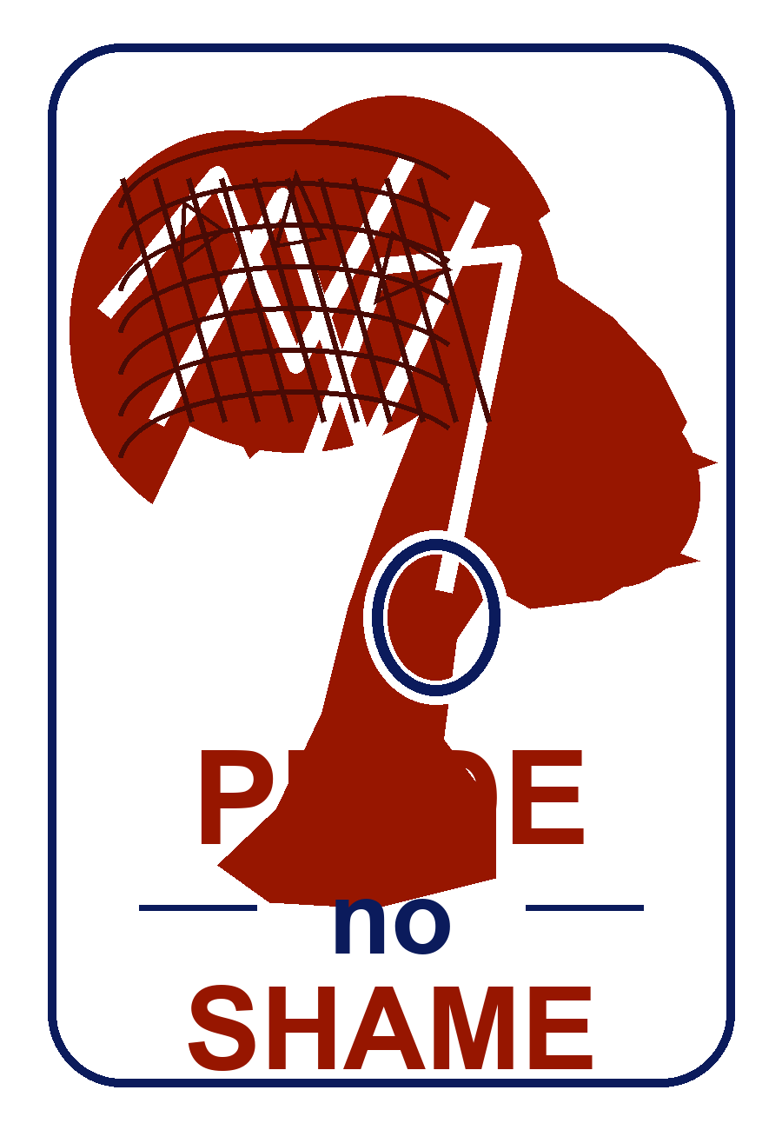
FRIENDS OF HUMANITY & PRIDE NO SHAME
Second Quarter 2026 Report
Progress Update, Humanitarian Care, and New Initiative Readiness

Reporting period | April - June 2026
Prepared for | Donors, partners, and potential investors
Prepared by | Pride No Shame / Friends of Humanity
Post-quarter note | Includes urgent medical follow-up planned for Saturday, 8 August 2026
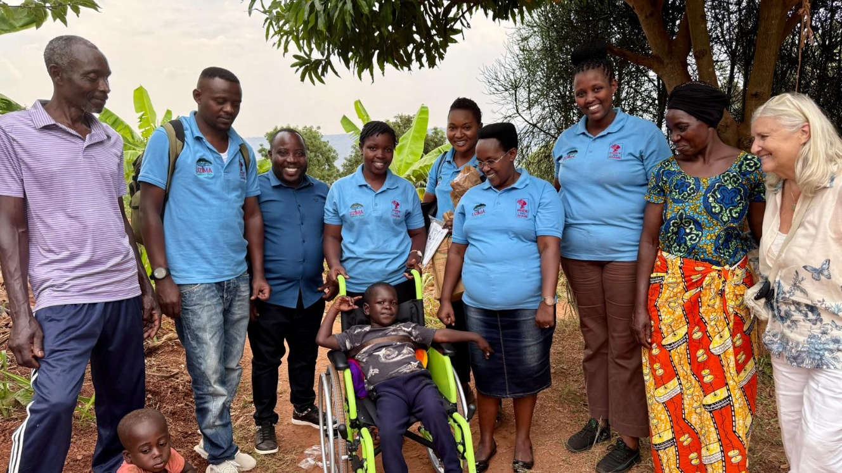
Field support and partnership image from the 2025 Pride No Shame impact report.
Dignity, health, and opportunity for women, girls, and vulnerable families.

Executive Summary
During the second quarter of 2026, Pride No Shame moved from foundational planning toward implementation readiness. Building on the first-quarter market research and the 2025 impact work, the organization focused on maintaining humanitarian support for Messi, advancing the new sanitary pads initiative, refining the phased production pathway, and continuing discussions with strategic partners and potential buyers.
Q2 Focus | The quarter centered on three linked priorities: protecting Messi's medical and nutritional progress, preparing sanitary pad sample testing and market validation, and strengthening donor/investor readiness for a phased production and distribution model.

- Messi's nutrition and care continued, with his weight improving from 8 kg at baseline to approximately 19 kg, creating the conditions for renewed neurosurgical assessment.
- The sanitary pads initiative was refined into four phases: sample testing, 500,000-pad procurement and market validation, factory set-up with imported machines and raw materials, and longer-term local raw-material manufacturing.
- Pride No Shame continued working closely with Rucci and Legacy Foundation to take the new initiative to the next level, including budget estimation based on market research findings.
- Potential collaboration discussions continued with UNICEF Rwanda, YWCA, local distributors, and other actors in the menstrual health and hygiene space.
- Market interest from local distributors should be treated as conditional until products are received, tested, and formally confirmed.

Progress Since the First Quarter
Area | Q1 foundation | Q2 progress
Market intelligence | Market research identified demand, affordability barriers, quality expectations, and distribution needs. | Findings were used to estimate budgets, define market testing, and guide conversations with potential buyers and partners.
Partnerships | Rucci/Legacy Foundation alignment was identified as a major pathway for scale. | Collaboration continued to advance the new initiative, infrastructure thinking, and project planning.
Humanitarian care | Messi's medical, nutritional, social, and rehabilitation support continued. | Monthly nutrition support continued; weight gain and overall progress made neurosurgery consultation the next required medical step.
Implementation readiness | Need for sample testing, quality validation, and market entry planning was identified. | A four-phase pathway was shaped, beginning with sample distribution and two-month user feedback.
Q2 progress against first-quarter foundations.

Humanitarian Support: Messi
Messi remains a priority humanitarian case for Pride No Shame and Friends of Humanity. The continued support reflects the organization's commitment to dignity-driven care beyond menstrual health programming. During the reporting period, nutrition support, monthly food delivery, and medical follow-up remained essential to his progress.

Medical and Nutrition Progress
- Monthly food support continued, including nutrient- and vitamin-rich items required to improve strength, weight, and general health.
- Messi's weight improved from approximately 8 kg at the start of support to approximately 19 kg.
- This progress is significant because the neurosurgery team previously advised that Messi needed to gain weight before a procedure could be considered.
- A neurosurgery consultation is planned for Saturday, 8 August 2026, to assess the next steps and determine whether surgery is possible or advisable.

Note Medicale en Francais
L'annee derniere, Messi a ete amene chez un orthopediste a Gatagara pour une prise en charge orthopedique visant a corriger et soutenir ses membres. Grace a l'amelioration de son etat nutritionnel et a la progression de son poids, il est maintenant au niveau ou une consultation en neurochirurgie peut etre envisagee. La neurochirurgie avait auparavant recommande une augmentation de son poids avant de decider si une intervention chirurgicale pouvait etre initiee.
Support area | Status | Next step
Nutrition | Monthly food and nutrition support continues. | Maintain delivery of nutrient- and vitamin-rich food items.
Medical follow-up | Weight and health progress now support neurosurgical review. | Attend neurosurgery consultation on Saturday, 8 August 2026.
Rehabilitation and orthopedic care | Gatagara orthopedic care supported limb correction and positioning needs. | Continue follow-up based on medical recommendations.
Family support | The support has reduced pressure on a vulnerable family. | Keep case monitoring active and document needs clearly for partners.
Messi support status and immediate next steps.

New Sanitary Pads Initiative
The new sanitary pads initiative is being positioned as both a social impact program and a sustainability pathway. It responds to the market research findings that affordability, quality, comfort, absorbency, and supply reliability are central to adoption. The project is also intended to guide donor and investor discussions on Rwanda's sanitary pads market, community demand, possible local production, and future regional expansion.

Strategic Partners and Market Engagement
- Rucci and Legacy Foundation: continued collaboration to take the initiative to the next level, including infrastructure planning and project development.
- UNICEF Rwanda: potential partner for menstrual health, WASH, adolescent wellbeing, and access for vulnerable groups.
- YWCA and other community organizations: potential community-level partners for outreach, women's engagement, and education.
- Local distributors: early market research indicates interest in buying, but this should be confirmed only after products are received, tested, and accepted.
- Potential buyers and partners: conversations are ongoing and should be supported by clear samples, pricing, quality data, and an implementation plan.

Four-Phase Implementation Pathway
Phase | Description | Purpose / decision gate
1. Sample testing | Receive samples from the manufacturer and distribute approximately 50 samples to women for two months of testing and feedback. | Confirm comfort, quality, absorbency, sizing, packaging, user acceptance, and price expectations before larger procurement.
2. Initial procurement and market validation | Procure 500,000 sanitary pads, with a target to sell 50% as part of market testing and sustainability validation. | Test distributor demand, community sales, affordability, logistics, and revenue potential before factory investment.
3. Factory set-up | Set up production infrastructure using imported machinery and imported raw materials. | Move from procurement and distribution toward local production once demand, quality, and buyer interest are confirmed.
4. Local raw-material manufacturing | Explore local production of selected raw materials in Rwanda when market volume justifies the investment. | Reduce import dependency and build Rwanda-based supply-chain resilience over time.
Phased pathway for the new sanitary pads initiative.

Sample Testing Plan
Testing element | Planned approach
Sample volume | Approximately 50 samples from the manufacturer.
Target users | Women and girls representing the priority market segments, including community users where possible.
Testing period | Two months of use and feedback collection.
Feedback topics | Comfort, absorbency, thickness, leakage protection, skin comfort, packaging, price perception, and willingness to buy.
Decision output | A short sample-testing report with user feedback, product recommendations, and go/no-go guidance for the 500,000-pad procurement phase.
Recommended sample testing structure.

Budget and Investor Readiness
The budget is being estimated based on market research data and ongoing discussions with potential partners. For donor and investor discussions, the report should show a clear link between demand, affordability, supply reliability, phased investment, and measurable social outcomes. The financial model should remain staged so that larger factory and raw-material decisions are made only after sample testing and early market validation.
Investor question | Current answer / preparation need
Is there demand? | Market research indicates recurring demand and willingness to consider affordable local products.
Will buyers accept the product? | Acceptance must be confirmed through two-month sample testing and distributor feedback.
Can the first procurement be sustainable? | The 500,000-pad phase should test whether at least 50% can be sold while maintaining impact access.
When should factory investment happen? | After product acceptance, pricing, distributor demand, and working-capital needs are better validated.
When should raw materials be localized? | Only after Rwanda and regional demand justify the scale and investment needed.
Donor and investor discussion points.

Risks, Assumptions, and Mitigation
Risk / assumption | Mitigation
Distributor interest may not convert into confirmed purchase orders. | Use samples, pricing sheets, product specifications, and written buyer feedback before counting demand as confirmed.
Sample testing may identify product quality or sizing concerns. | Capture structured feedback and request manufacturer adjustments before bulk procurement.
500,000-pad procurement may create stock or cash-flow pressure. | Phase distribution, pre-identify buyers, and balance sales with donor-supported access.
Factory set-up may require higher capital and technical support than expected. | Finalize project plan, implementation plan, equipment quotations, raw-material supply plan, and land/rental cost assumptions before commitment.
Messi's medical pathway may change after neurosurgery consultation. | Document the doctor's recommendation and update the care plan, budget, and family support needs accordingly.
Key risks and mitigation actions.

Priorities for the Next Quarter
- Ensure Messi attends the neurosurgery consultation and document the medical recommendation and next steps.
- Continue monthly nutrition and vitamin-rich food support for Messi without interruption.
- Receive manufacturer samples and implement the two-month user testing process.
- Prepare a short sample-testing results report with product acceptance, user feedback, and recommendations.
- Finalize the project plan and implementation plan for partner and investor sharing.
- Continue engagement with UNICEF Rwanda, YWCA, local distributors, Rucci, Legacy Foundation, and other potential partners.
- Advance budget and financial modeling for the 500,000-pad procurement phase, factory set-up, and later raw-material manufacturing option.

Conclusion
The second quarter of 2026 shows Pride No Shame moving from research and strategic preparation toward structured implementation. The organization has a clearer pathway for testing product acceptance, validating distributor demand, preparing procurement, and sequencing future manufacturing investment. At the same time, the continued care for Messi demonstrates the organization's people-centered mission and the importance of sustained donor support. The immediate priorities are to complete Messi's medical follow-up, launch sample testing, confirm partner and buyer commitments, and finalize the project and implementation plan for the next stage.

